**Chassis:**

* **What is Chassis:**

Chassis is nothing but the Trailer who provided The Services:

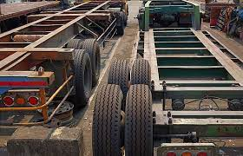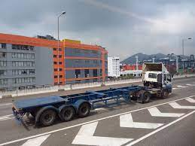

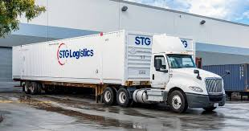

A chassis is the load-bearing framework of a manufactured object, which structurally supports the object in its construction and function. It is the foundation on which all other components of the object are mounted.

Here are some of the key functions of a vehicle chassis:

* Supports the weight of the vehicle and its occupants
* Provides a mounting point for the body, engine, transmission, and other components
* Absorbs and distributes forces from the road and other impacts
* Protects the occupants from harm in the event of a collision

**Container:**

* **What is Container:**

Container is nothing but standard cargo unit that can be transferred between ships, trucks& trains

20 feet & 40 feet Containers mostly used in **STGI**

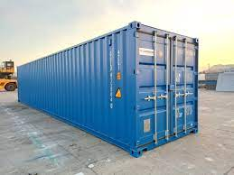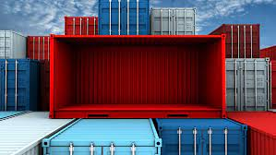

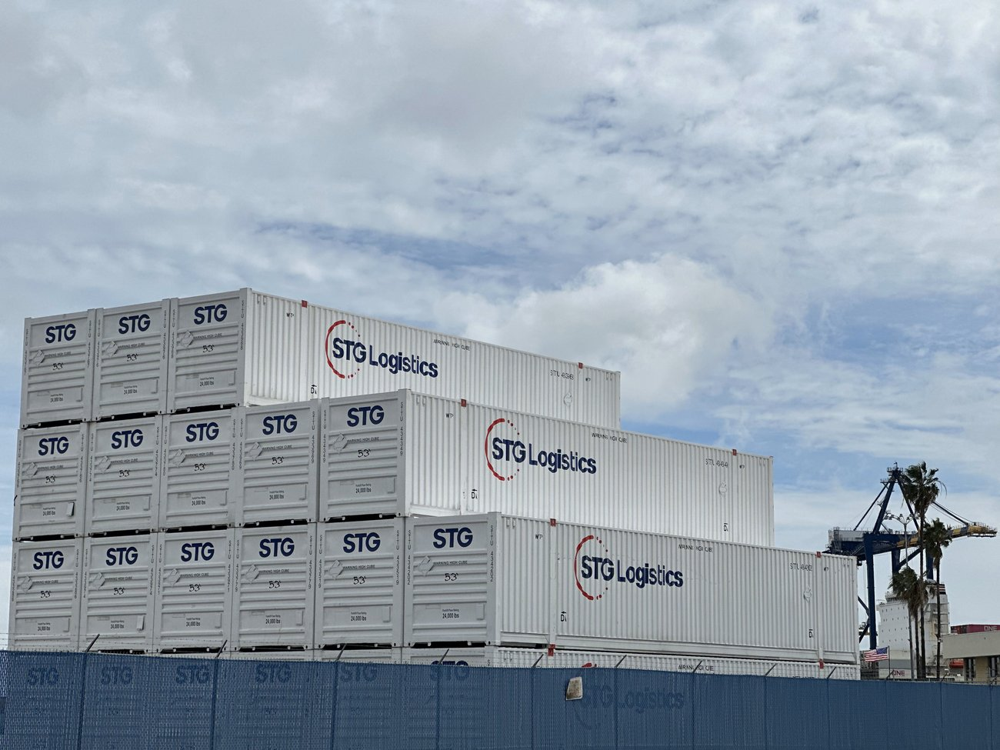

Containers are used to transport a wide variety of goods, including food, beverages, electronics, clothing, and machinery. They are also used to transport hazardous materials, such as chemicals and explosives.

Here are some of the benefits of using containers in logistics:

* Efficiency: Containers can be loaded and unloaded quickly and easily, which reduces shipping times and costs.
* Safety: Containers are secure and protect goods from damage during transport.
* Versatility: Containers can be used to transport a wide variety of goods, including bulk cargo, general cargo, and specialized cargo.
* Sustainability: Containers are reusable and can be recycled at the end of their lifespan.

**Equipment:**

**What is Equipment:**

Equipment is a tool used in Transport like Container, Forcipes, missionary, Vehicles & crane etc.

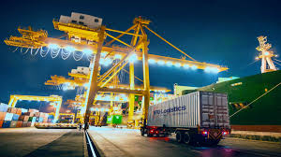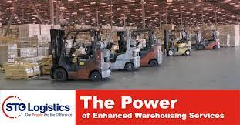

Logistics equipment is any type of machinery or tool used to move, store, or handle goods. It is used in a wide range of logistics operations, including transportation, warehousing, and picking and packing.

There are many different types of logistics equipment, but some of the most common include:

* Forklifts: Forklifts are used to lift and move heavy objects. They are essential for loading and unloading trucks and trailers, and for moving goods within warehouses.
* Pallets: Pallets are flat platforms on which goods can be stacked and moved. They make it easier to handle large quantities of goods, and they can be used with forklifts and other material handling equipment.
* Conveyors: Conveyors are used to move goods from one place to another. They can be used to move goods within a warehouse, or to load and unload trucks and trailers.

**Need of Chassis Board:**

* **Separate chassis board required for monitoring and tracking of chassis easily.**
* **Chassis board containing only chassis data makes it very easy to track and monitor.**
* When a user assigns this chassis to multiple customer orders, it is easy to do so because of the separate chassis board, which contains the latest update of the chassis.
* **Help to maintain the workflow of Chassis.**
* **Chassis board contains all STG chassis data, so it's very easy to maintain the chassis update (maintenance, servicing, or other work).**

**Chassis Board Screen :**

**How we can create Chassis on RO:**

**Which Filer we have to check On chassis Board:**

|  |
| --- |
| Equipment # ID |
| Equipment Size |
| Equipment Type |
| Attach Equipment |
| Last Event |
| Last Event site |
| Last Event Date |
| Event Dweel |
| Customer |
| OGT Dweel |
| Bad Order |
| Ram Resion |
| Ground Resion |
| RSc Resion |
| Chassis Owner |
| Bare Chassis |
| Xpo wheels |
| Last Ram |
|  |
| Market |
| Lease No. |

**Details Info OF Each Filter & How we can verify:**

* **Create new CO (C020)**
* **Cerate ne Eqp.**
* **Create a new Chassis!**
* **Follow the steps & move the CO to Complete status.**
* **Verified the Wo generated or not.**
* **Go to the first rail WO & add events (IGT, OGT, TRV, TRD, TRL& NOT…ETC)**
* **Add one event & verified it on Chassi board it gets reflect or not.**